📝 READ CAREFULLY: The Workflow: Interview prep + Consent form
Hi! We’re excited to feature you in The Workflow, a bi-weekly source of AI and automation playbooks for people who use tech to get real work done, not just share FOMO on LinkedIn.
This doc has two parts:
- A few light prep questions
- A short content usage agreement (so we can share & repurpose your brilliant system with proper credit)
________________________________________________________
1️⃣ INTERVIEW QUESTIONS
👋INTRO

- For anyone who hasn’t stalked your LinkedIn yet, tell us who you are, what you do, and where you spend most of your ‘get-shit-done’ energy these days.

- Before we get into your workflow, let’s talk about the current AI noise. What’s one thing you’ve read or heard about AI lately that you think is completely overhyped, scared the hell out of you, or is just plain wrong? Is there a specific post, claim, or ‘miracle use case’ that made you roll your eyes?

____________________________________________________________

🛠️THE WORKFLOW

Introduce your workflow like it’s a superhero or a movie star.
- What are their unique powers? Why are they famous?

What problem were you trying to solve when you built this workflow?
- What was the measurable outcome you were aiming for?
- What wasn’t working or was inefficient in your previous setup?

Walk us through it step by step, sharing your screen (you will need to prepare that in Miro or somewhere similar in advance and upload it to the Google Folder we shared.)

We are looking for something like this

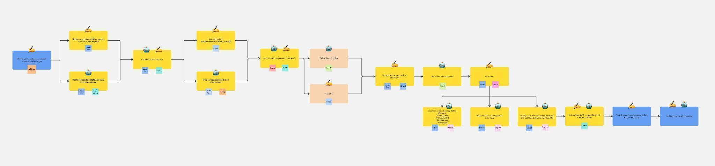
- Where does the workflow start and end?
- What triggers it? What loops are built in?
- What tools are used in each step? Why specifically those?
- What’s manual vs automated?
What kind of results did you get from this?
- What surprised you, either in a good or chaotic way?
- What saved you time/money/headaches?
- Did something totally break? Any tool limitations?
- What would you not automate again because manual still does better?
____________________________________________________________
✨ THE GOLDFLOW
Zooming out — what did this workflow teach you about marketing, automation, or how you work best?
- When does automation make sense, and when does it not?
- What’s a principle or belief this process confirmed for you?
____________________________________________________________

🗂️ DOCUMENTATION
Please see the email we sent you and the interview invite for instructions on what to do and where to upload assets.

2️⃣ CONTENT RELEASE & USAGE AGREEMENT
To make sure we’re all aligned, please read and agree to the terms below before the interview.
✅ WHAT YOU’RE AGREEING TO
By participating in the interview, you grant us permission to:
- Record, edit, and publish your interview in written, audio, and video form
- Share it via our newsletter, social channels, website, podcast, YouTube, and other owned or paid distribution platforms
- Reuse the content in future monetized products like paid templates, whitepapers, digital libraries, courses, or newsletters
- Allow us to make reasonable edits to improve clarity, length, or formatting
We will:
- Credit you clearly and visibly whenever we share content originating from your interview — including your name, role, and LinkedIn (or preferred link).
- Respect your intellectual property: we won’t claim ownership of the workflow you shared or any content that’s clearly based on your personal experience.
You will:
- Retain full ownership of your personal brand and proprietary methods.
- Have the right to review the published version and request reasonable edits within 5 business days of publication.
- Acknowledge that once published, the content may be reused or monetized as outlined above — with clear attribution — and that you won’t be entitled to royalties, commissions, or any financial compensation resulting from that monetization.

